Beautiful Feet Dance Spring 2019 Session
Calvary Chapel of Delaware County
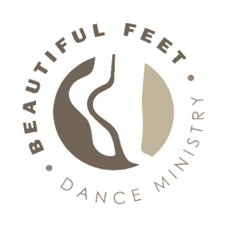
Instruction in a variety of dance forms including: Ballet, Jazz, Lyrical/ Contemporary, Tap, Worship and Fitness

WEDNESDAYS- January 23- May 1st (No class week before Easter)
4:15pm- 5:15
- Tots- 3-5 yr. olds (must be 3yrs. by December- 2018)
- Kids- 6- 8 yr. olds
- Tweens- 9- 11 yr. olds

5:15- 6:45pm
- Intermediate/ Advanced Ballet/ Contemporary- 12 yrs. - Adults (younger by audition)

5:15- 6:15pm
- Beginner Ballet/ Worship/ Fitness—12 yrs.- Adults (younger by permission)

THURSDAYS, January 24- May 2nd (No class week before Easter)
5:00- 6:30pm
- Intermediate/ Advanced Ballet/ Contemporary- 12 yrs.- Adults (younger by audition)

SATURDAYS, February 2- April 27th (no class weekend before Easter)
8:30- 9:30am- FREE DEMONSTRATION Class: January 19th/ Class starts Feb. 2nd
- Body and Soul DANCE BLAST FITNESS- 12 yrs.- Adults
Register at: https://bodyandsoul.org/for-students/register-for-class/ Cost is $60 for 12-week session

9:45- 10:45am- Starting February 2nd- May 4th
- Tap- Beginner- Intermediate 12 yrs. – Adults (younger by permission)

ATTIRE: Children- Teens: Black leotards, dance school/camp t-shirt/ (to be purchased) and black exercise pants. Teens/ Adults wear tank top/ t-shirt over leotard)/
FITNESS & TEEN/ADULT Tap- comfortable workout clothes and sneakers

SHOES: All ages: Pink Ballet shoes, Black Oxford tap shoes, Sneakers for Fitness

COST: $120 for 15-week session, $20 off each additional class and/or sibling(s)
- BALLET BUNDLE! If you take both Inter/Adv classes session cost is: $175!
- Teen/ Adult Tap 12-week session- $95
- Costume fee: $30 for dance classes added to each tuition.
RECITAL INFORMATION: Sunday, May 5th, 2019
WHERE: Calvary Chapel of Delaware County, 500 Brandywine Dr., Chadds Ford, PA 19317
REGISTER: Please go to: https://ccdelco.ccbchurch.com/goto/forms/226/responses/new
QUESTIONS?: Please email: dfitzpatrick@ccdelco.com OR visit our Website: http://beautifulfeetdanceministry.com/
Facebook: https://www.facebook.com/BeautifulFeetPraise/
Opportunities to present our dances in service projects and extra performances to be announced

